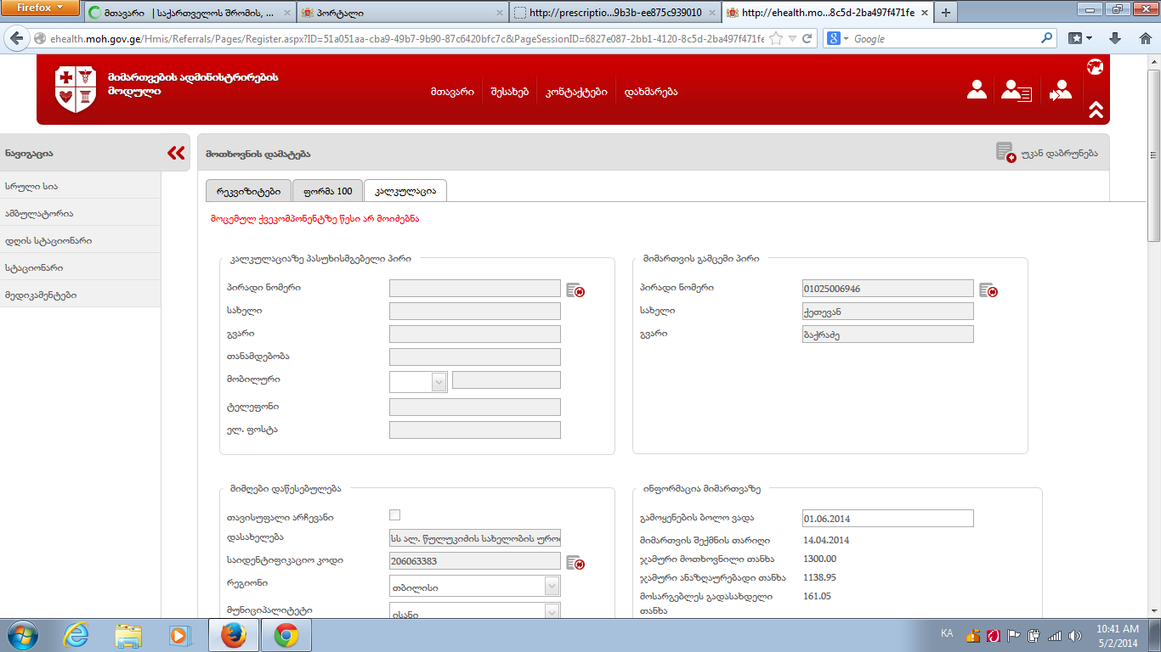
P/N 01003021009 - 90081

